Dear u3a Friends,

Hey-up! It’s cracking the flags at last!
There are some time-critical events in this newsletter. Get along to the Coffee Morning on Thursday next for free coffee and biscuits and a chance to steer your u3a into new activities. Join the committee – nominations must be in by May 15th. Sign up for a day out.
If you would like to join the birdwatching group, we have spaces. You might see a bittern, a gadwall, a kingfisher or a little egret. But you will not see any of the birds in these photographs from Alan Wade. Thank you, Alan, for bringing us something exotic. There is so much to read in here that I have no room for jokes. Instead the joke is on me – there is an easter egg over there that I can’t seem to get rid of…
In this issue:
- News and Information
- Monthly Meetings
- Outings and Foodies
- Social Events
- U3a Groups
At-a-glance: Littleborough u3a May Calendar
Thursday May 7th | Littleborough u3a Coffee Morning | 10am in Littleborough Coach House. Free and open to all members
Monday May 11th | U3a Monthly Meeting: Steve Lister – The wonders of the Ukulele and its tunes | 2pm in Littleborough Coach house. £1 for members on the door
Monday May 18th | Littleborough u3a Committee Meeting | 10 am Hare Hill House
Wednesday May 20th | Outing to York | Pick up Littleborough and Rochdale
Thursday May 21st | Quiz | 2.30pm Red Lion Pub
Thursday May 28th | Craft Group | 1.30 pm Hare Hill House
Thursday June 4th | Littleborough u3a Walking Treasure Hunt | 2pm Hare Hill House
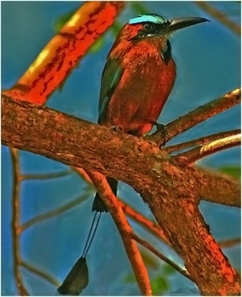
Pendulum Bird, Mexico. Looking hot!

- News and Information
Littleborough u3a Annual General Meeting
The AGM will be held at the monthly meeting on Monday June 8th at 2pm. I sent you the formal invitation and the documents with the last newsletter but do feel free to message me if you would like another copy. We will not be printing documents for everyone but the agenda and the annual accounts will be on the screen for you to see. Paper copies of the form to nominate yourself or someone else to the committee can be picked up at the monthly meeting. There will also be paper copies of the proxy form if you want to appoint somebody else to vote on your behalf at the AGM.

We are looking forward to welcoming some new members onto the committee this year and we would be very pleased if you wished to join them.
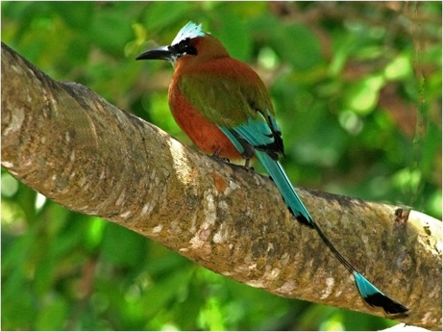
This year the AGM will be followed by lively performances from our musical groups: the ukulele band, the guitar group and the u3a choir. Our spoken word performers will be performing at the Listen Up event in July.

This pendulum bird is showing off his tail.


- Monthly Meetings
Our next Monthly Meeting will be on Monday May 11th at 2pm in Littleborough Coach House. It will feature our own member, Steve Lister talking about The Wonders of the Ukulele. Steve will talk about song writing and perform a selection of his own songs and poems. Expect some nostalgia, a few laughs and thought-provoking lyrics from the leader and teacher of the Ukulele Group.

At our April meeting, Chris Verey gave us a tour of the Town Hall, with some stories and a close look at some of the amazing features so that we could see how those angels in the big hall are constructed and how they look different after the renovation. It was a most interesting exploration of a truly remarkable building.

- Outings

A Day Out in Whitby. If you don’t know it, there is the Captain Cook museum, the famous Magpie Fish and Chip shop for both takeaway and restaurant meals, a stretching walk up to the abbey on the cliffs, lots of great little shops and a very picturesque harbour.
This is a u3a member trip picking up in Littleborough and Rochdale as usual. The cost of the coach is £33. You can sign up for the trip at the monthly meeting in May but please then book directly with Ellen Smith’s Coaches – this avoids us taking in the money then transferring it to them. Please call them on 01706 648126.
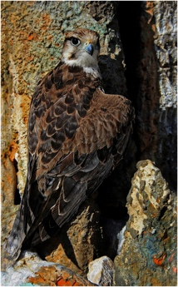
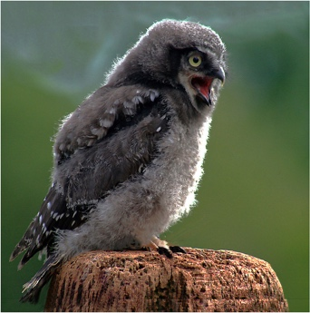
young spectacled owl and eagle camouflaged on the rockface.

- Social Events
Here is the programme of upcoming social events. We expect these to be popular so please sign up soon. More details are below the table.
We are currently planning for the events that will happen from September. We have a number of ideas but please come along to the coffee morning with your suggestions.
7 May 2026 | Coffee morning – a chance for new and existing members to learn about what u3a offers, groups, talks, events and how best to get involved. Contact Sue Temperley: https://littleborough.u3asite.uk/u3a-contact-form/?contact_id=20372 | 10 to 12am | Coach House | Free
4 June 2026 | Walking Treasure Hunt, starting at Hare Hill House. Book your place by emailing Jacqui Mellor: https://littleborough.u3asite.uk/u3a-contact-form/?contact_id=20427 | 1 to 4pm | Hare Hill House | £1.00
13th June 2026 | Cycle Ride – see details below | 9am to 11.30 | Start at the bike shop on Canal Street | No charge
18 June 2026 | Rosalind Harrison’s talk about her work as a magistrate – book your place via Sue Temperley – see above. | 2 to 4pm | Hare Hill House | £1.00 on the door
30 July 2026 | Listen Up! A chance to be entertained by our creative writing, poetry and play groups. Contact Sue Temperley (see above) | 2 to 4pm | Coach House | £1.00 on the door

PLEASE COME TO OUR u3a MAY COFFEE MORNING NEXT WEEK!
Thursday 7th May
Start: 10am
Coach House
- An opportunity to have your say about the new social events we’ve been organising this year
- A chance to chat about what we do next and how we do it
- An informal opportunity for new members to come and find out about Littleborough u3a and meet other u3a members.
This is a free event. Please just come along.

Looking forward to seeing you there.
Sue Temperley


Littleborough park last week
Thursday June 4th:
A WalkingTreasure Hunt, 2pm - starting and finishing at Hare Hill House, Littleborough.

Join us for a walking treasure hunt around Littleborough.
Working in teams of 2 or 3 (you can join a team on the day), you will set off at intervals of a few minutes. You'll be given a set of directions to follow. It will take about 60 minutes, please be sure to wear suitable clothing for the weather and be aware of the traffic on your route.
There'll be a prize for the team who complete the hunt in the shortest time.
You'll need to bring £1 (in change please) for this event.
Refreshments will be available at Hare Hill House after the hunt.
Sign up at the monthly meeting or see contact in the table above.


Saturday June 13^{th.} Littleborough u3a BIKE RIDE!
Yes – the first ever Littleborough u3a Bike Ride, suitable for all cyclists. Numbers are limited for this one so please be sure to sign up – details below.

Howard Gott, experienced cyclist and cycle ride leader, says:
The ride will start at 9am from the Coffee Stop and bike shop at Ealees on Canal Street.
It will be suitable for all levels of fitness, and we won’t leave anyone behind. The route will be: Canal towpath towards Walsden — regrouping at locks/steep climbs/bridges, and dismounting when necessary. Bottomley, near Walsden — turn left onto the main road here, towards Littleborough. There is a footpath beside the road for less confident riders (pedestrians have priority). Toll House/Calderbrook Road — stop at the turning space opposite, cross the main road into Calderbrook Road. Calderbrook Road — dismount at the road break; continue to the Community Primary School.
Turn Left towards the Cricket Club, right past the library, finish at the park cafe, where a table is booked for 10.30. Here you can buy yourself a well-deserved drink.
There will be a sign up sheet at the monthly U3A meeting, or you can contact Howard Gott at: https://littleborough.u3asite.uk/u3a-contact-form/?


Thursday June 18th: My Experiences as a Magistrate: A talk from member Rosalind Harrison about her. experiences as a magistrate in Rochdale. Rosalind will tell us about the people who worked in the court and recount some of the things that happened, revealing no identities, for this is a setting in which things are bound to happen. Numbers are restricted in Hare Hill House so please sign up at the monthly meeting or contact Sue at: https://littleborough.u3asite.uk/u3a-contact-form/?contact_id=20372


Thursday July 30th: LISTEN UP! This is where you will hear what our Creative Writing, Poetry Appreciation and Playreading groups get up to. You will be treated to a selection of poems, stories and one short play. Entertainment guaranteed. It’s an afternoon of culture and laughter. With cake and tea and coffee. All for £1 payable on the door. Sign up at the monthly meeting.

Last Month’s Events
Anita Elwell’s talk about her brother was so interesting both because of the life of Potts the clown and because of the coincidences and the way in which they had met each other after more than 60 years. In part it was a story about an extraordinary career and in part a sad tale of how connections are lost when children are split up when they are small, then found and forged in later life. We are grateful to Anita for a fascinating afternoon (and there was also some delicious cake!).
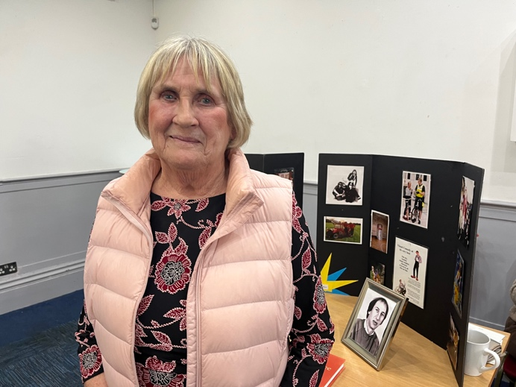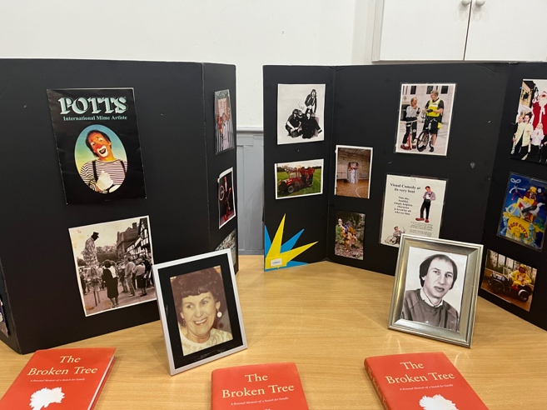

A word from the grandson of one member, a little boy they are trying to ensure knows not to repeat rude words. His grandad has lots to say about the US President. So little Finley says:
“Nana, grandad keeps trumping!”

- Groups

New Beginners’ Guitar Group now started. If you want to sign up, you can do so at the monthly meeting or by contacting our Groups Coordinator: https://littleborough.u3asite.uk/u3a-contact-form/?contact_id=20377


Littleborough u3a CHOIR
Everyone can sing!! (oh yes, they can!)
We have been delighted recently to welcome several new members (men and women) to the choir.
Singing is so good for us – helping both our physical and mental health, so if you enjoy singing, whether you can read music or not, whether you’ve sung in a choir before or not, our choir is for you - why not give it a try and have some fun?
We meet every Tuesday (except the last one in the month) at the Coach House at 1.15 til 2.30. Next session: Tuesday 5th May.


Quiz Group next meets on Thursday May 21st in the Red Lion. Pub on Halifax Road in Littleborough at 2pm (teams are decided when you get there)

The Craft Group will be making Summer Wreaths on Thursday May 28th in Hare Hill House

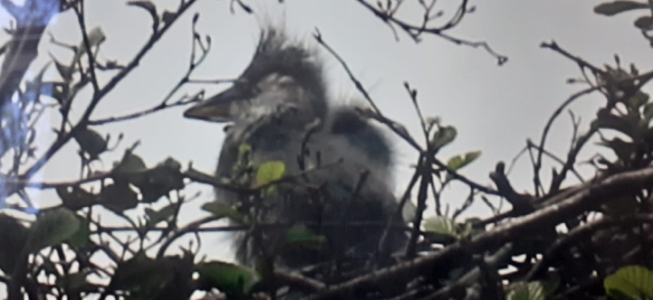
And, finally, a bird from closer to home – baby heron at Queen’s Park in Heywood. This comes from one of our u3a birdwatchers. Thank you John.


We’ve been especially lucky this Easter break, celebrating across two Bridge groups with plenty to share. Tuesday brought us a lively clue based challenge with well earned Easter Eggs for the winners, and Friday’s general knowledge quiz resulted in well earned prizes for our winners — all enjoyed alongside delicious hot cross buns.
Today was our pinnacle moment: Helen treated the Tuesday group to a glorious Victoria sponge that vanished at impressive speed, which tells you everything about how good it was.
We’re now toying with the idea of an in-house competition to test what we’ve learned from Dave’s mini lessons — today’s Gerber and Blackwood lesson, plus a chance to practise slams (or wisely avoid them). A festive, thoughtful, and very enjoyable fortnight all round.
If you’re interested in learning to play or brushing up your Bridge skills, we offer a beginners’ Friday morning session, an intermediate Tuesday morning group, and an
advanced Friday evening group.
Please contact me via the website. Christine

Many congratulations to the Beginners Bridge Group, marking their first anniversary this May 2026. A wonderful achievement built on enthusiasm, learning, and teamwork.
Well done to all involved. — Chris Veevers

That’s all for this month but there is plenty here to keep us busy. I hope you have enjoyed this newsletter.

Very best wishes to you all.
Jo Wiggans
Littleborough u3a Newsletter editor.

