LITTLEBOROUGH U3A
DAY EXCURSIONS WITH ELLEN SMITH TOURS
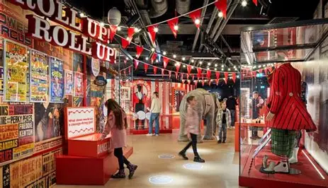
Wednesday 15th April 2026 Showtown Museum Blackpool & Lytham £34.00 per person
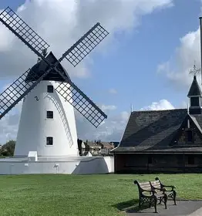
Following our departure this morning we head to Blackpool to the Showtown Museum where there are immersive displays and interactive displays. The museum is the Winner of Exhibition of the Year 2025. There are six galleries that bring to life the best of the seaside, magic, circus illuminations, shows and dance. Discover the stories of the comedians, dancers, acrobats and characters who turned Blackpool into the home of show business.
After visiting the museum, we head to Lytham St Anne’s for some free time. Lytham St Anne’s offers a relaxed seaside escape with plenty to fill your day. You can start with a walk along the beautiful promenade, enjoying sea views and the town’s iconic Victorian charm. Visit the Lytham Windmill to learn about local history and snap a few great photos. If you like shopping, Clifton Street has a mix of boutique stores and cozy cafés to explore.

Wednesday 20th May 2026 York £28.00 per person
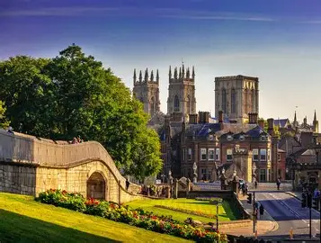
Following our departure this morning we head to York, a city where history and charm blend beautifully, offering plenty to see and do. You can wander along the ancient City Walls for stunning views, explore the magnificent York Minster, a masterpiece of stained glass and stone. take yourself to The Shambles to look at the quaint shops or grab yourself something to eat in one of the quaint eateries. History lovers can visit the Jorvik Viking Centre, York Castle Museum or Cliffords Tower, take a lovely walk along the River Ouse or take in the sights with a peaceful river cruise.

